Location and time activated reminder service with map service

- Deliverables :-

This app that lets you do some pre-planning to make setting reminders even easier. Add your favorite places in advance to set reminders with just a few taps. It also has a timer feature so you can set reminders for a specific time after arriving or leaving a place. It also provides feature for some time based task, such as Monthly bills with features “When to pay and where to pay”. It reminds you the task which can be done by traveling few distance or within some time limit from the place you are currently at.

- Methodology to be adopted for the implementation of the project:-

We will be using waterfall model for app development
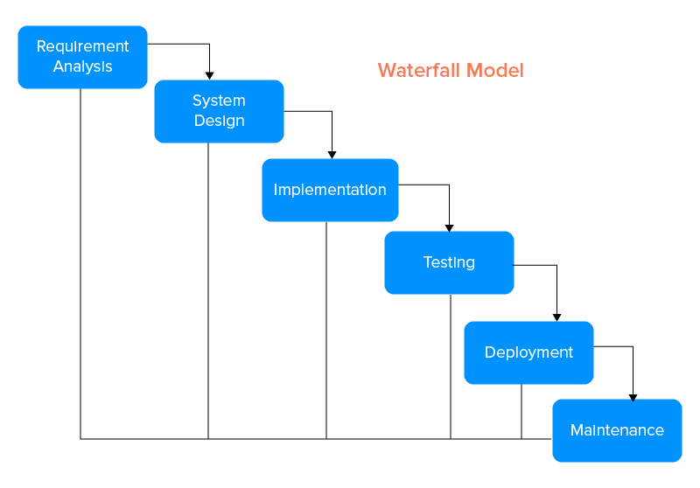

- As requirement/functionalities of the app is fixed, it will be easier to follow waterfall model for the app. It includes going step by step through different stages in which output of one stage is input for next stage.

- Progress made so far :-

I’ve built two apps. One includes interface while other is for demonstration purse.

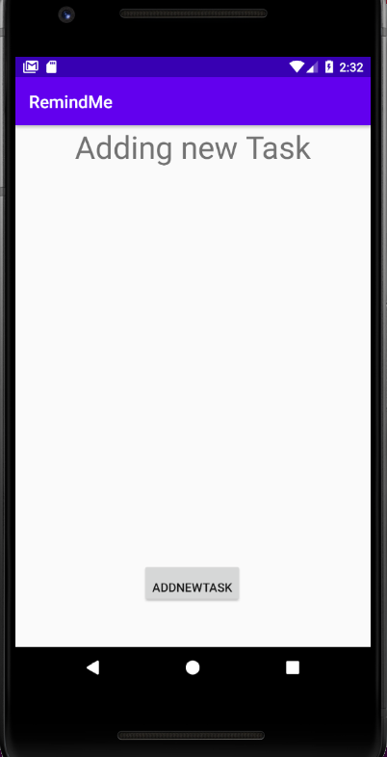
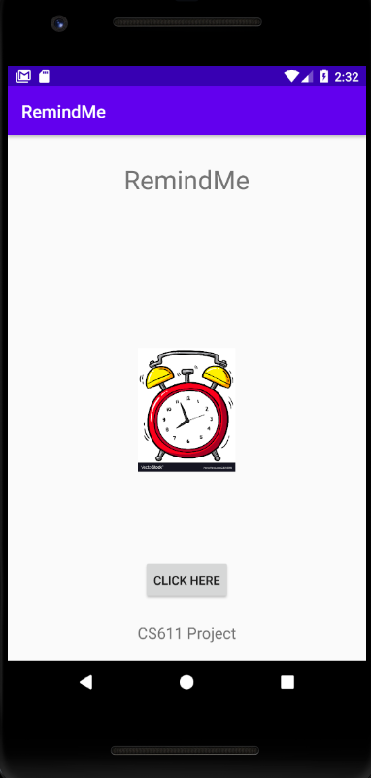

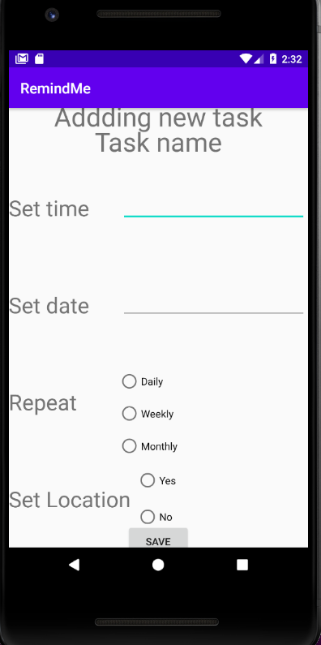
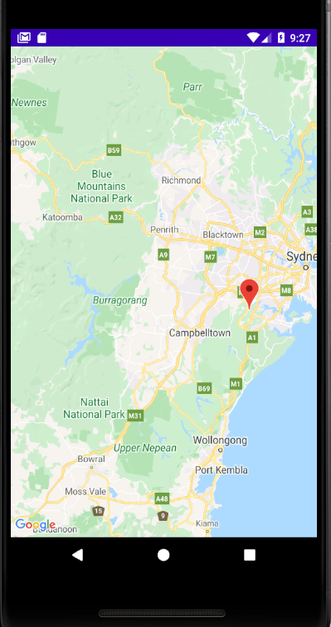

WORKING:-

- Interface includes Setting time, Setting date, Repeatation(whether user wants repeatation) and setting Location for the task.

- All the location(remainders) are saved in two arrays, one contains latitude of the location while other contains longitude of the location.

- I’ve mark some locations for remainder purpose.

- In every user touch on map, all the remainders are checked whether they are in-range of reminding task(For this app I’ve taken 20k.m). However we may change it according to our needs.

- If the task is under set range, the app will notify the about the task.

- Initially plan was to give the input of the current location by user touch, but somehow app is not working that way. So, we have to give latitude and longitude of the current position manually.

VAIBHAV K VERMA
11841260

